

**LEGADO MUNOZ CHARDONNAY 2016. CASTILLA.**

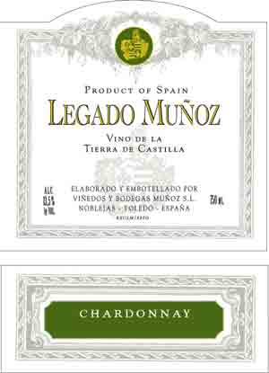

**VARIETAL:** 100% unoaked Chardonnay

Estate grown and bottled.

**TASTING NOTES:** Straw yellow in the glass with complex aromas of tropical fruits (pineapple, mango) with citrus underpinnings. Expressive and fruit forward with good freshness and a smooth, well-rounded finish.

The Munoz family owns 80 Has (200 acres) of carefully selected vineyards around Noblejas. Careful selection of the vines, crop thinning and poor calcareous soils combine to produce concentrated and structured wines. Yields are kept significantly lower than what is usual in the region. The average age of the vines is 30 years. Only native yeasts are used.

The family recently acquired a former 17th century subterranean cellar excavated in the rock. The installations are being painstakingly restored and are being used already to age the top wines of the Estate in perfect conditions of temperature and humidity. Bottling takes place after a very light filtration. In 2004 Bienvenido was chosen Winemaker of the Year in Castilla la Mancha.

